**“Experiment 1.4”**

Student Name: **SUMIT KUMAR** UID: **20BCS8226**

Branch: **CSE** Section/Group: **808-A**

Semester: **5** Date of Performance: **25-08-22**

Subject Name: **PBLJ Lab** Subject Code: **20CSP-321**

**AIM**:

Create a program to set view of Keys from Java Hashtable.

**Minimum Hardware Requirements:**

* 2 GHz CPU or 1 virtual CPU in virtualized environments.
* 1 GB of RAM.
* 4 GB of storage.

**Minimum Software Requirements:**

|  |  |
| --- | --- |
| **Software** | **Version** |
| * OS | * Mac OS 10.15, HP-UX 11i V3, AIX 7.2, Windows Server 2019, Windows 10, Solaris 11.3, Red Hat Enterprise Linux 8.1, Ubuntu Server 20.04 |
| * JDK | * JDK 1.8.0, JDK 11, Ellipse IDE, Net, NetBeans 8.2 |

**Source Code:**

// SUMIT KUMAR

// UID: 20BCS8226

**package** practice2;

**import** java.util.Enumeration;

**import** java.util.Hashtable;

**public** **class** Keys {

**public** **static** **void** main(String[] args) {

Hashtable ht = **new** Hashtable();

ht.put("1", "One");

ht.put("2", "Two");

ht.put("3", "Three");

Enumeration e = ht.keys();

**while** (e.hasMoreElements()){

System.***out***.println(e.nextElement());

}

}

}

**Output:**

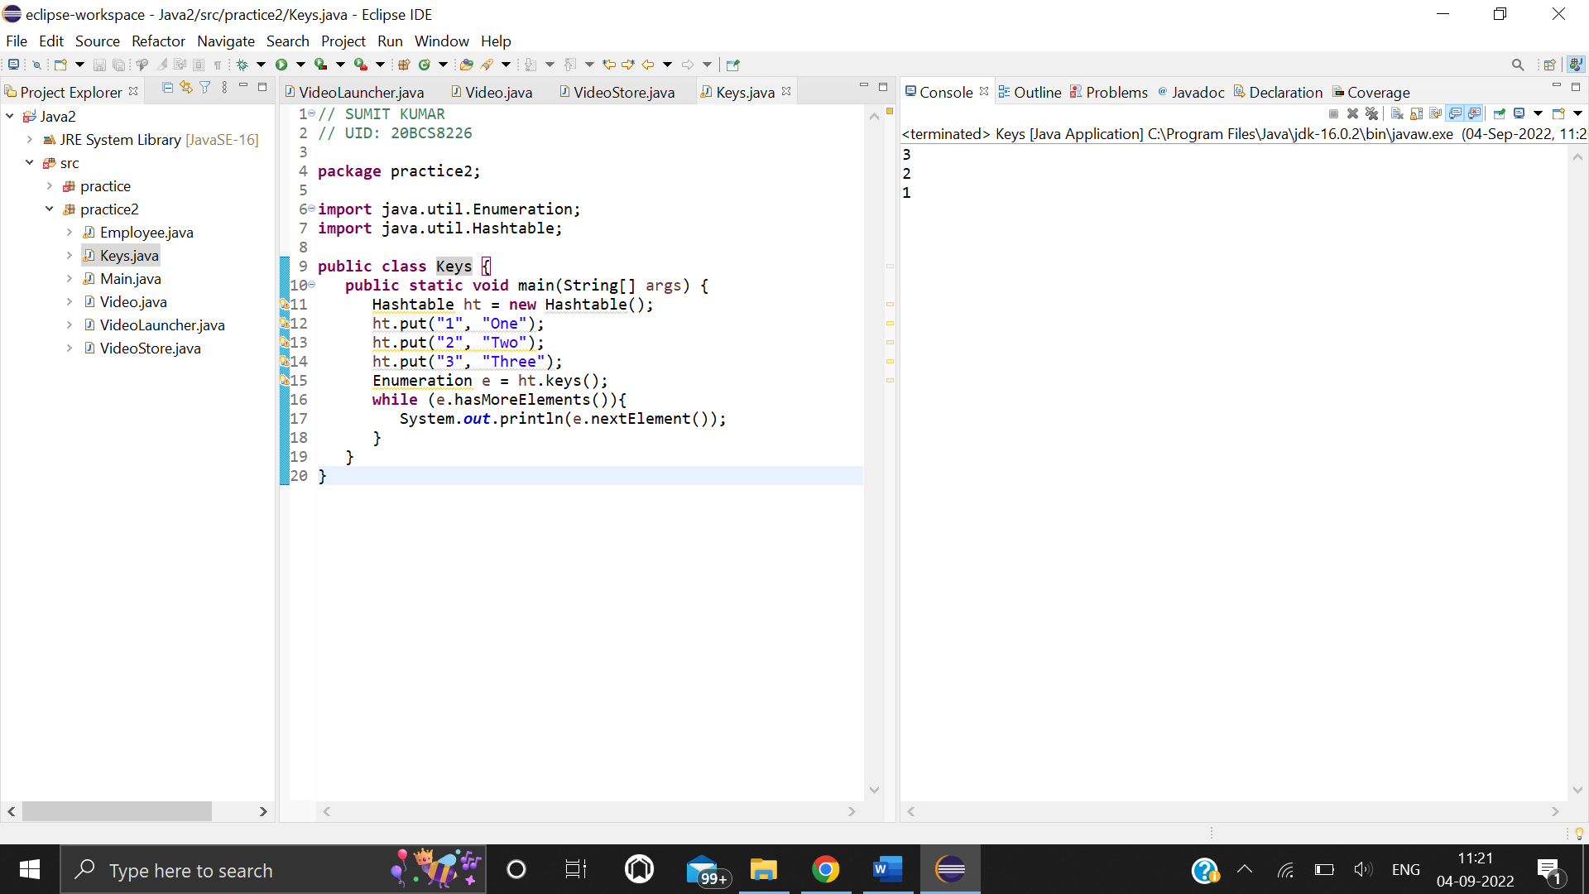

**Learning outcomes (What I have learnt):**

1. Learn that hashtable stores key/value pair in hash table.
2. Learnt that in order to remove an element from the Map, we can use the remove() method.
3. Learn that the hash function helps to determine the location for a given key in the bucket list.